 | 8.3.2 Editors - Image Editor - Sidebar - Image Tab
Table of content
Introduction 2
Image Panel 3
Source 3
Source Type Generated 3
X / Y 3
Float Buffer 3
Generated Type Blank 3
Color 3
Generated Type UV Grid 3
Generated Type Color Grid 3
Color Space 4
Half Float Precision 4
View as Render 4
Seam Margin 4
Source Type Movie + Image Sequence 4
Path edit box 4
Pack 4
Path edit box 4
Open 5
Refresh 5
Info string 5
Frames 5
Match Movie Length 5
Start 5
Offset 5
Cyclic 5
Auto Refresh 5
Deinterlace 5
Color Space 5
Alpha 6
Half Float Precision 6
View as Render 6
Seam Margin 6
Source Type Single Image 6
Path edit box 6
Pack 6
Path edit box 6
Open 6
Refresh 6
Color Space 6
Alpha 7
Half Float Precision 7
View as Render 7
Seam Margin 7
Source Type Udim 7
Info string 7
Color Space 7
Alpha 7
Half Float Precision 7
View as Render 8
Seam Margin 8
UDIM Tiles Panel 8
UDIM Tile List 8
Number 8
Drag Handler 8
Search Field 8
Invert 8
Sort by Name 8
Add Tile 8
Add Tile dialog 9
Number 9
Count 9
Label 9
Fill 9
Color 9
Width / Height 9
Alpha 9
Generated Type 9
32 bit float 9
Remove Tile 9
Fill Tile 9
Fill tile dialog 10
Color 10
Width / Height 10
Alpha 10
Generated Type 10
32 bit float 10
UDIM Workflow 10
Metadata Panel 12

Introduction

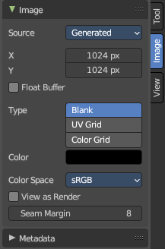
In the Image tabs you can find further options and image settings. These settings changes, dependent of what you have selected. And in what mode you are

Image Panel

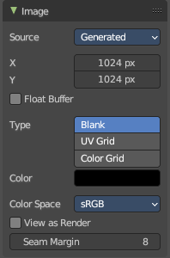
Find image related settings. Size, type, and so on.

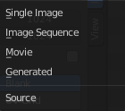
Source
Choose the image type. This type gets usually automatically set. When you create a new image, then this image is generated. When you load an image then the Source switches to Single Image.
Generated images does not have a path.

Source Type Generated

X / Y
The image width and height.

Float Buffer
Use a floating point buffer. 8 Bit images uses integers. 32 Bit works with floats.


Generated Type Blank
This type displays an image with one blank color

Color
The color of the blank image.


Generated Type UV Grid
This type displays a with a black and white checker texture but colored dots.


Generated Type Color Grid
This type displays a with a colored checker texture with numbers.


Color Space
Choose the color space type for the image.

Half Float Precision
Just with image material that uses 32 bit float. Use just 16 Bit per channel instead of the full 32 bit. This lowers the memory usage while rendering.

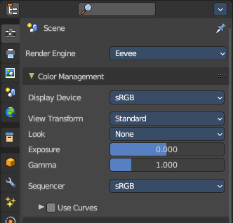
View as Render
Display the image with using the color management settings. The color management can be adjusted in the properties editor in the Render tab.

Seam Margin
This option belongs to the UV Editor, and has no effect in the Image editor. Take a margin into account when fixing UV seams during painting.

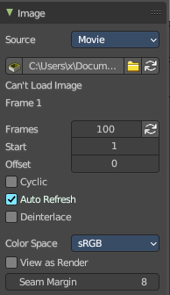
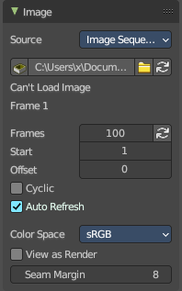
Source Type Movie + Image Sequence


Path edit box

Pack
With this button you can pack the movie or the image sequence into the blend file. It gets packed when you save the blend file the next time.

Path edit box
See and edit the path to your movie or image sequence files.

Open
Open a new movie or image sequence files. A file dialog will appear.

Refresh
Reread the movie or image sequence files.

Info string
Some information about the currently loaded movie. Frames, resolution and color space.

Frames
The number of frames of the movie or image sequence.

Match Movie Length
Set Users Image Length to the one of this video.

Start
The start frame of the movie or image sequence

Offset
Offset the number of the frame to use in the animation. -1 means off.

Cyclic
Cycle the images in the movie.

Auto Refresh
Always refresh image on frame changes.

Deinterlace
Deinterlace the movie file on load.


Color Space
Choose the color space type for the movie or image sequence files.

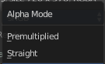
Alpha
Choose the alpha channel mode. Straight or Premultiplied.

Half Float Precision
Just with image material that uses 32 bit float. Use just 16 Bit per channel instead of the full 32 bit. This lowers the memory usage while rendering.

View as Render
Display the image with using the color management settings. The color management can be adjusted in the properties editor in the Render tab.

Seam Margin
This option belongs to the UV Editor, and has no effect in the Image editor. Take a margin into account when fixing UV seams during painting.

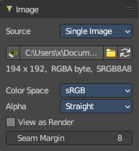
Source Type Single Image

Path edit box

Pack
With this button you can pack the movie or the image sequence into the blend file. It gets packed when you save the blend file the next time.

Path edit box
See and edit the path to your movie or image sequence files.

Open
Open a new movie or image sequence files. A file dialog will appear.

Refresh
Reread the movie or image sequence files.

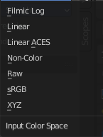
Color Space
The color space for the image.

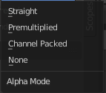
Alpha
How to calculate the alpha channel.

Half Float Precision
Just with image material that uses 32 bit float. Use just 16 Bit per channel instead of the full 32 bit. This lowers the memory usage while rendering.

View as Render
Display the image with using the color management settings. The color management can be adjusted in the properties editor in the Render tab.

Seam Margin
This option belongs to the UV Editor, and has no effect in the Image editor. Take a margin into account when fixing UV seams during painting.

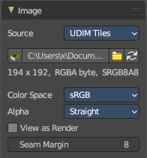
Source Type Udim
UDIM is an enhancement to the UV mapping and texturing workflow. And does not belong here. But in the UV Editor. It is just in the list because it shares the same menus with the UV Editor.

Info string
Some information about the currently loaded image. Resolution and color space.


Color Space
Choose the color space type for the movie or image sequence files.

Alpha
Choose the alpha channel mode. Straight or Premultiplied.

Half Float Precision
Just with color space sRGB. Use just 16 Bit per channel instead of the full 32 bit. This lowers the memory usage while rendering.

View as Render
Display the image with using the color management settings. The color management can be adjusted in the properties editor in the Render tab.

Seam Margin
This option belongs to the UV Editor, and has no effect in the Image editor. Take a margin into account when fixing UV seams during painting.

UDIM Tiles Panel

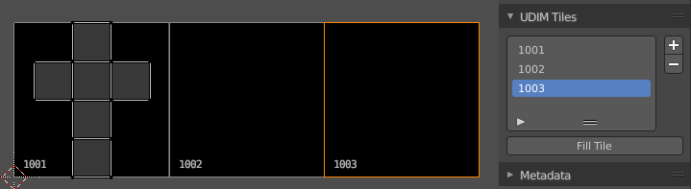
Manage UDIM tiles. This panel shows with source type UDIM.

UDIM Tile List
List all UDIM tiles associated with the main index (1000 tile). Double clicking on the tile name allows renaming.

Number
The starting tile index number. UDIMs must start with the 1001 tile and typically increase in incremental order.

Drag Handler
The two vertical lines at the end is a handler with which you can expand the list.

Search Field

You can expand a search field at the bottom of the list. Type in your term and hit enter to filter for your term.

Invert
Exclude the search term instead of searching for it.

Sort by Name
Sort the List by name.

Add Tile
Adds new UDIM tiles to the group.

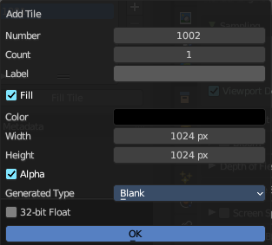
Add Tile dialog

Number
The UDIM tiles are identified by the number. It is four digits, and with increasing number.

Count
How many tiles to add.

Label
Leave blank to use the Number as the name in the list.

Fill
Fill the new tile with a generated image.

Color
The fill color for generated type Blank.

Width / Height
The dimensions of the image.

Alpha
Does the image have an alpha channel.

Generated Type
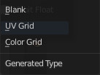
The generated texture type.

32 bit float
Generate an image with 32 bit floating point bit depth.

Remove Tile
Remove the selected UDIM tile. Note that the place in the texture will then be blank. The tiles does not resort. The next created UDIM tile will then be placed in this gap.

Fill Tile
Occupy the UDIM tile with a Generated Image. You can change the fill type and texture tile size of a UDIM tile also afterwards with this fill tool. Note that this overwrites the settings of the currently active UDIM tile.
Warning! If a tile is not filled, it will not be saved with the image.

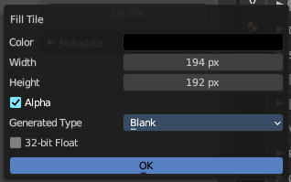
Fill tile dialog

Color
The fill color for generated type Blank.

Width / Height
The dimensions of the image.

Alpha
Does the image have an alpha channel.

Generated Type
The generated texture type.

32 bit float
Generate an image with 32 bit floating point bit depth.

UDIM Workflow
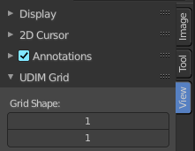
First set up the grid shape for the UDIM tiles.
This panel is in the View tab. And will vanish in the moment you add any texture. So do this setup beforehand. There is no way to show and change this grid panel afterwards.

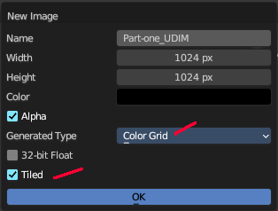
Unwrap your mesh.
Add a generated texture, with generated type Color Grid (optional ), and Tiled ticked.

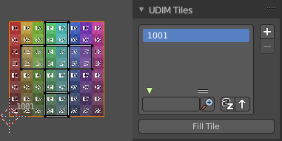
In the viewport you will now see one square UV space again, with the colored background image. And we have our first UDIM tile in the UDIM Tile list.

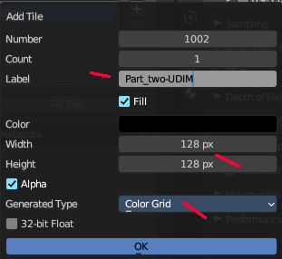
In the Tile list click at the Add button. And add another image. This time with another resolution.

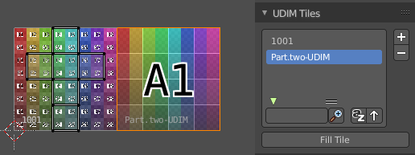
The result is that we have two tiles besides each other, with different resolution.

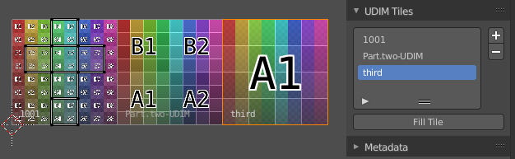
Create a third one. Or as much as you need.

Next move the UV parts to the texture areas where you need them.
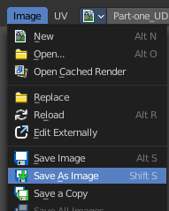
Now save the image. And by saving the one UDIM image all the sub images of this UDIM texture gets saved too.

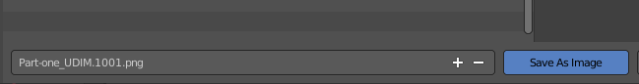

Save the blend file. Modify the textures to your needs.
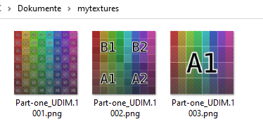
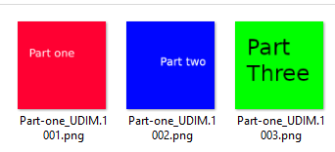

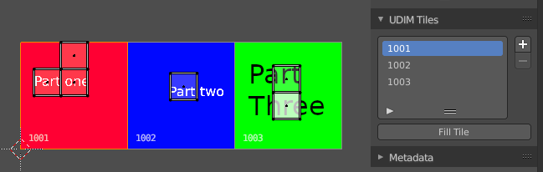
To reload the modified textures either save, close and open Bforartists and reload the scene. Or use Open Image to open the first image of the UDIM textures. The rest will load automatically.

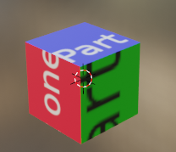
Next create a material. Add a texture. Choose the UDIM texture. And the material will now render with the UDIM textures applied.
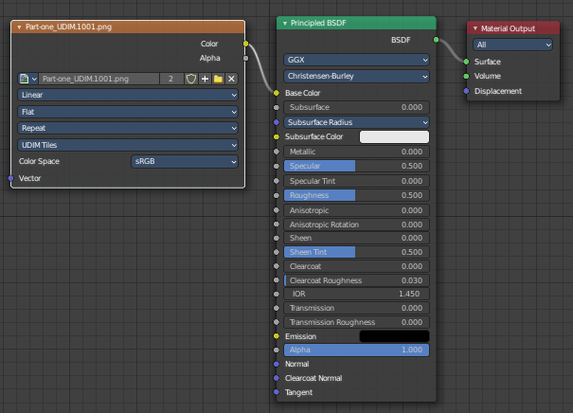

Metadata Panel

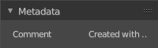
Displays existing meta data of the image file.

